**Deployment of Nodejs Application**

**Contents to check:**

There are two types of nodejs applications.

* Frontend nodejs Application.
* Backend nodejs Application.

*Frondend nodejs Application:*

* We have to check package.jason file to know the properties of the application

Note: Frontend application default port no. is **3000.**

*Backend nodejs Application:*

* We have to check package.jason file to know the properties of the application.
* Check whether it has the file with name ‘server.js’.
* Check the port No. in ‘server.js’ file

Note: Backend application has its port no. in ‘server.js’ file

**Requirements to Deploy a Nodejs Application:**

* OS.
* Server.
* Region to reduce Latency/Response Time.
* We have to install nodejs, npm.
* After installing npm we have to install pm2, serve and build using npm.

**Steps to deploy a Nodejs Application:**

1. Create a Server using any Cloud Service. Here we are using AWS to create a server.

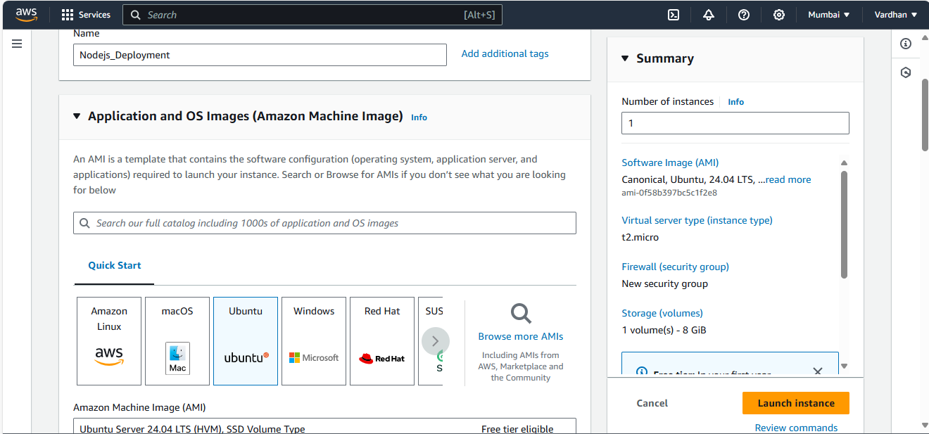

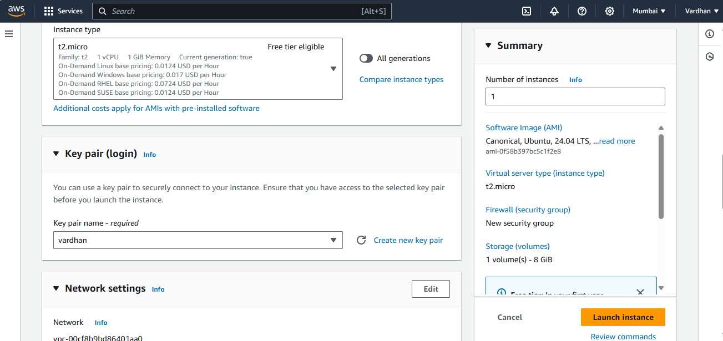

1. Login to your server using any SSH. Here we are using **Git Bash**.

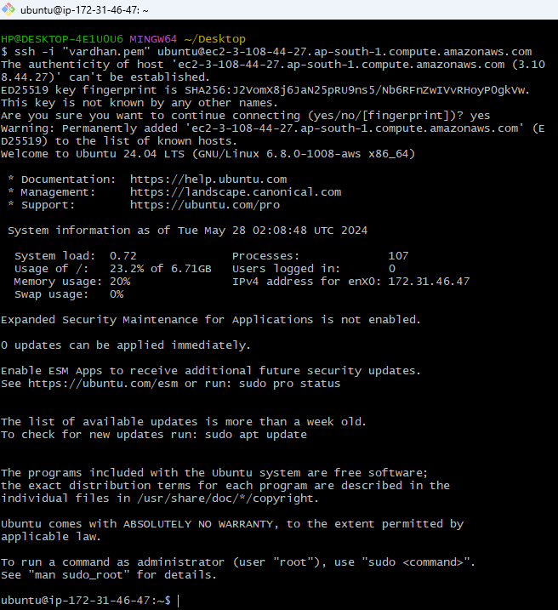

1. Update your server.

In Ubuntu Linux => **apt update**

In Amazon Linux => **yum update**



1. Install ‘nodejs’ to our server.

In Ubuntu Linux => **apt install nodejs**

In Amazon Linux => **yum install nodejs**

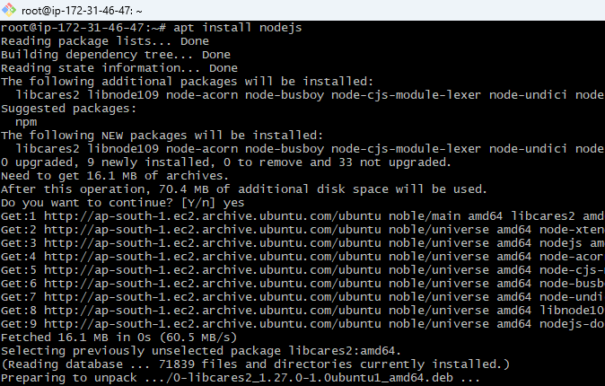

1. Install **npm** (Node Package Manager) to our server.

In Ubuntu Linux => **apt install npm**

In Amazon Linux => **yum install npm**

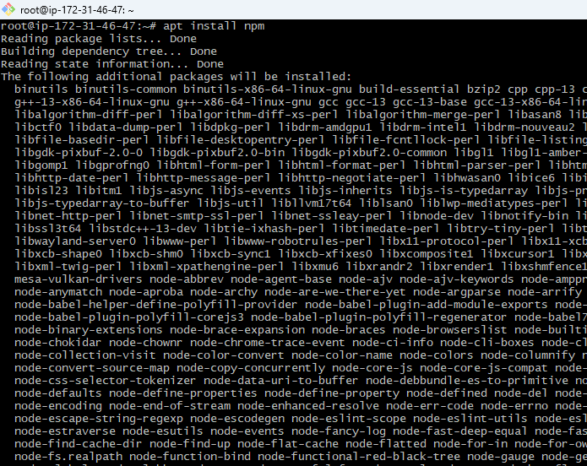

npm is used to resolve the modules, libraries and dependencies of the application.

1. Install **pm2** into our server using npm.

Command to install pm2 => **npm i -g pm2**

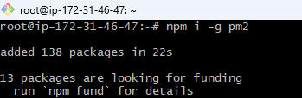

pm2 helps us to deploy our application permanently. It will stop working until we stop it.

1. Install **serve** into server using npm.

Command to install serve => **npm i -g serve**

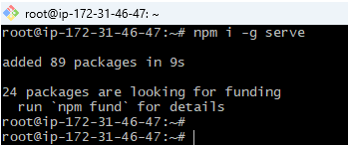

1. Here we have to import our application to our server. Here we are importing from github.

Command to import form github => **git clone < URL>**

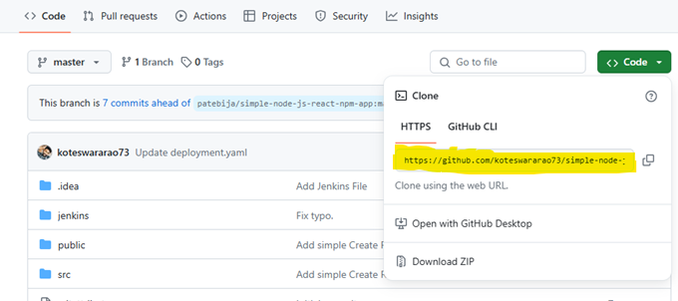

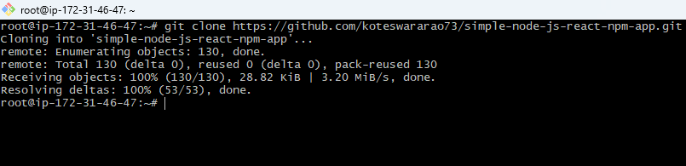

1. Open the directory of the application.

Command to open directory => **cd <directoryName>**

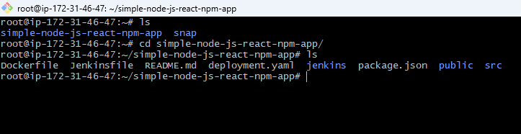

1. Resolve modules, libraries, dependencies using npm.

Command to resolve => **npm i**

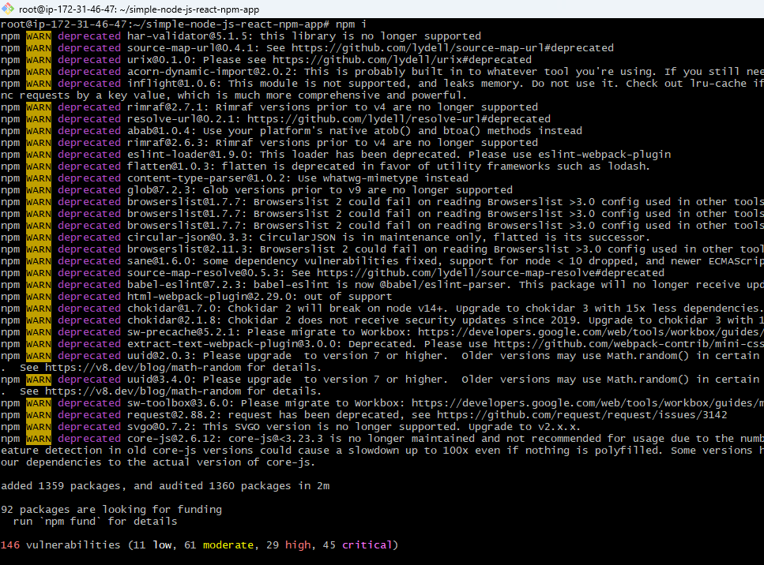

Here it creates a directory named ‘node_modules’.

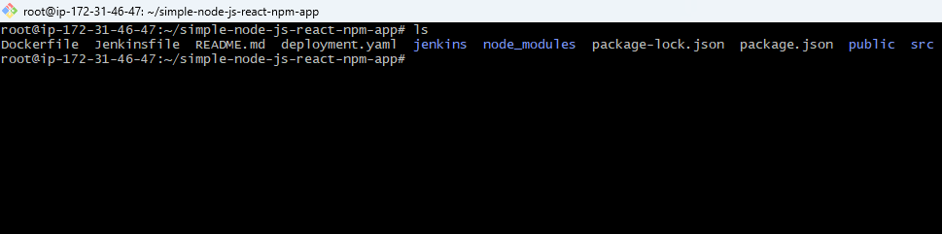

1. Create a build for an application using npm.

Command to create a build => **npm run build**

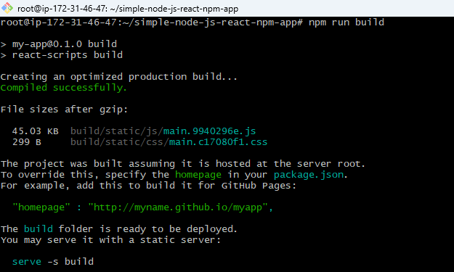

Here we have different ways for deploying Frontend Application and Backend Application

Note: frontend step 13 start from page No.7 and Backend step 13 start from page No.10

**For Frontend Application:**

After creating build of an application in Frontend it creates a directory with name ‘build’.

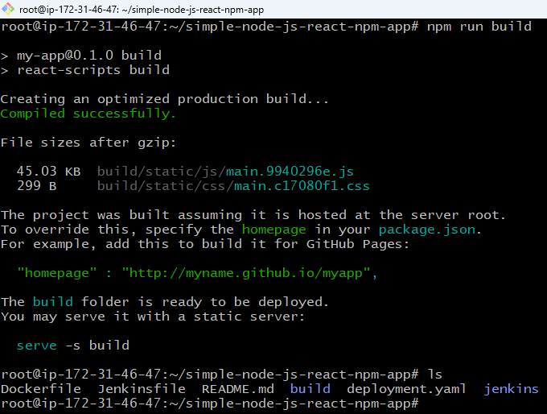

1. Now we have to serve the created build to a port no. using pm2.

Command to serve an application => **pm2 serve build <portNo.> --spa**

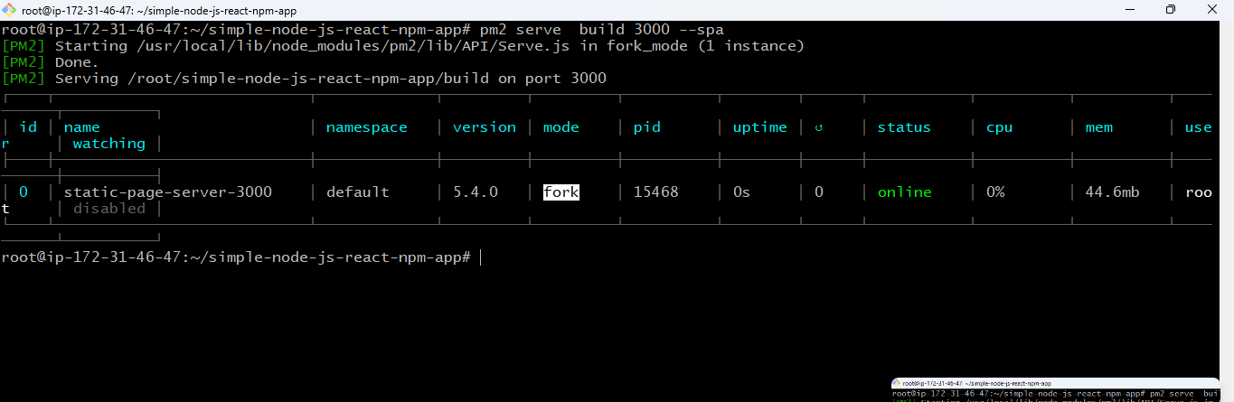

1. Save the configuration of application using pm2.

Command to save configuration of Application => **pm2 startup**

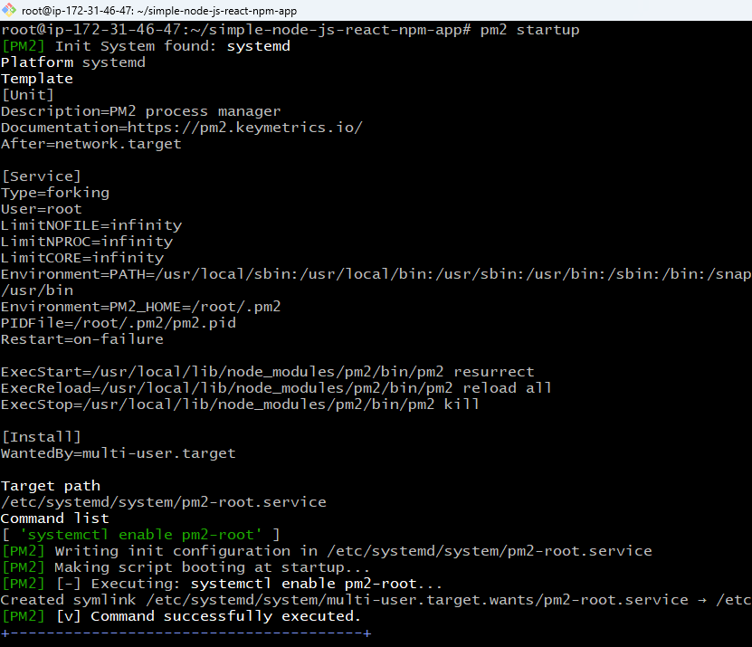

1. Save the configuration path permanently using npm.

Command to save configuration path => **pm2 save –f**

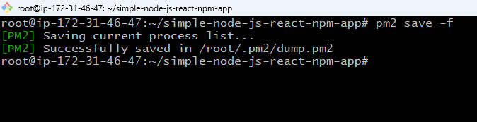

1. Go to Security groups and Allow required port in security groups to deploy Application in.

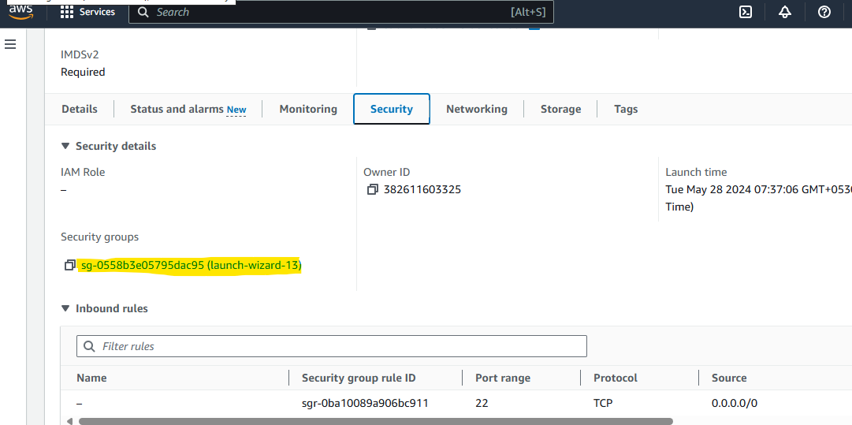

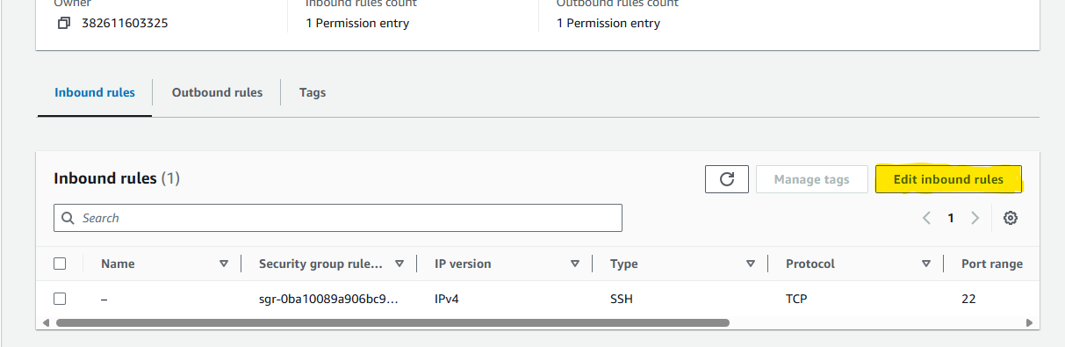

Port No. for frontend application is by default 3000.

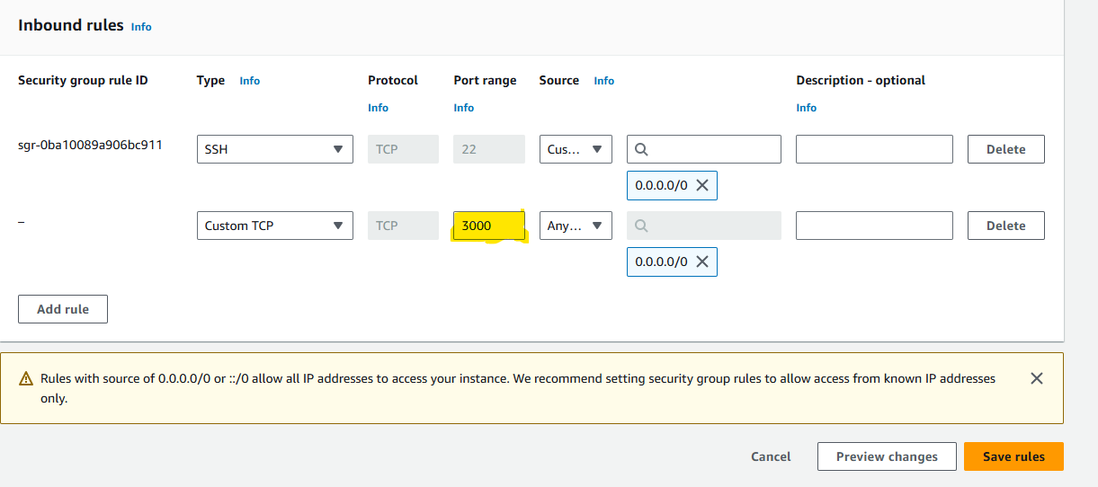

1. Here permanent deployment have completed, now you can check it by entering public IP along with port No. in URL of any browser.

===> <publicIP>:<PortNo.>

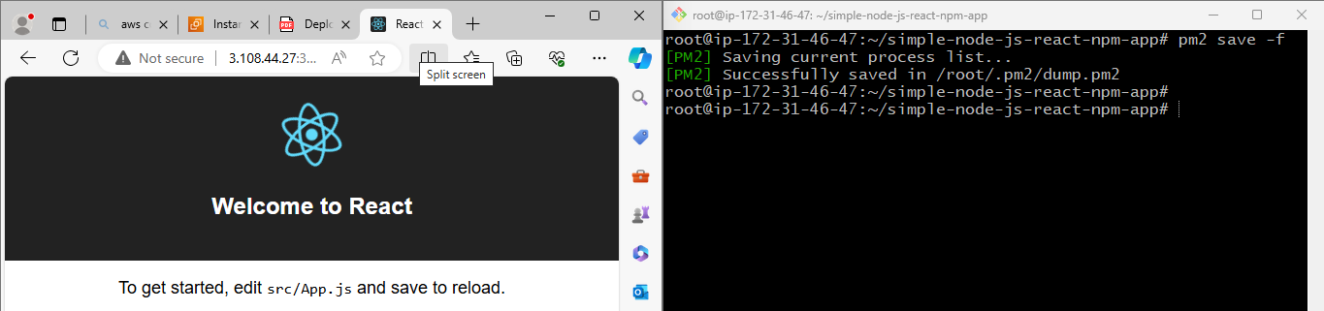

For temporary deployment we use command : **npm start build.**

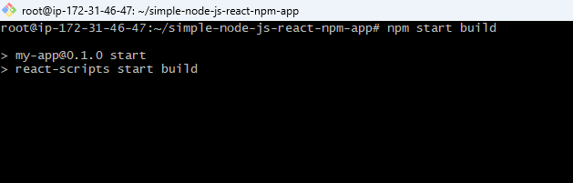

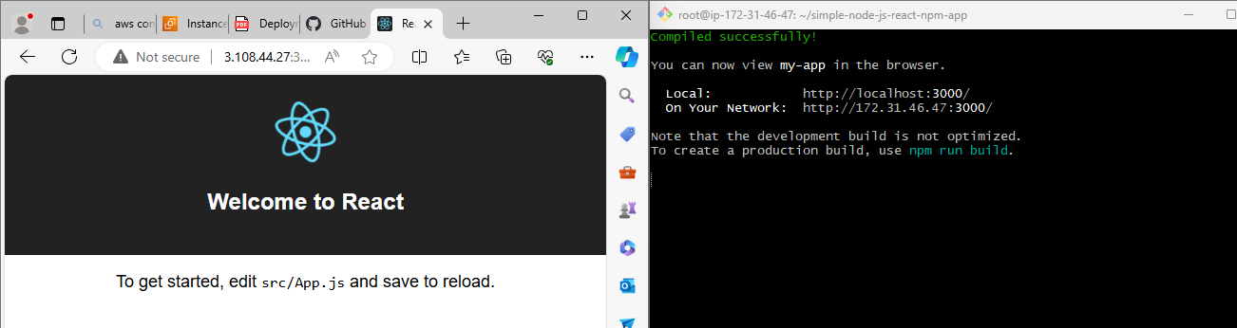

Once we exit that step it stops working.

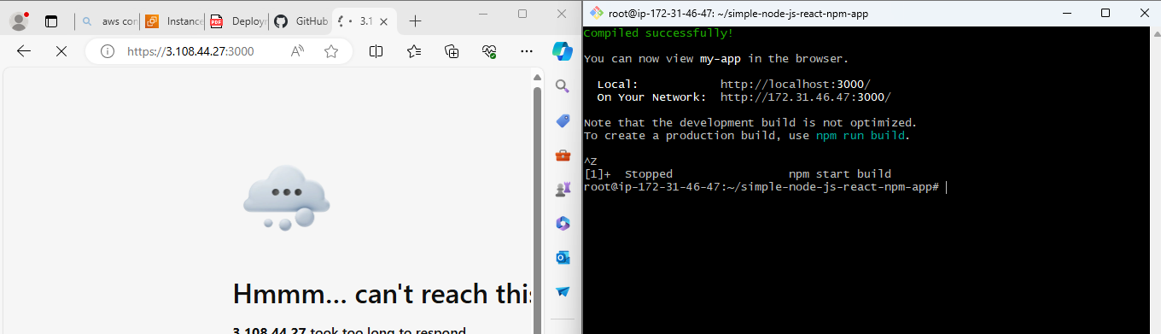

**For Backend Application:**

After creating build of an application in Frontend it creates a directory with name ‘dist’.

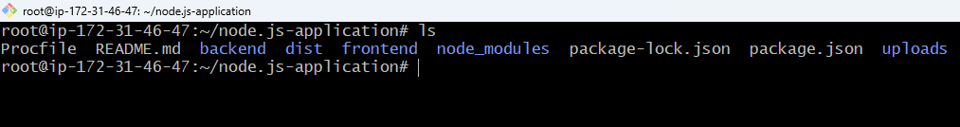

1. Now open the created directory ‘dist’

Command to open ‘dist’ directory => **cd dist**

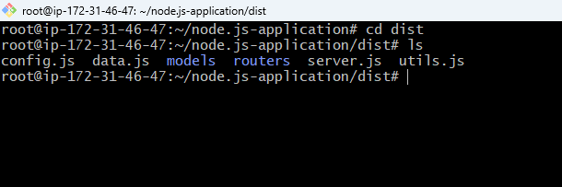

1. Now start ‘server.js’ file using pm2.

Command to start ‘server.js’ file => **pm2 start server.js**

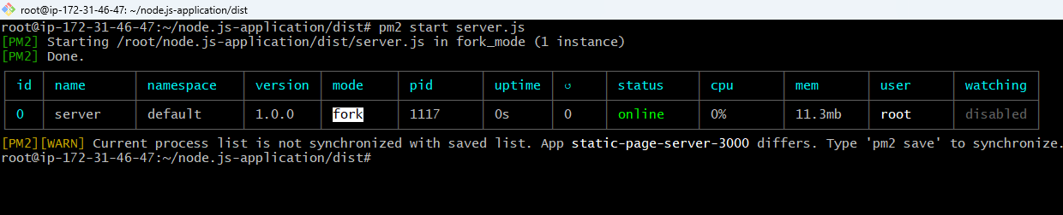

1. Go to Security groups and Allow required port in security groups to deploy Application in.

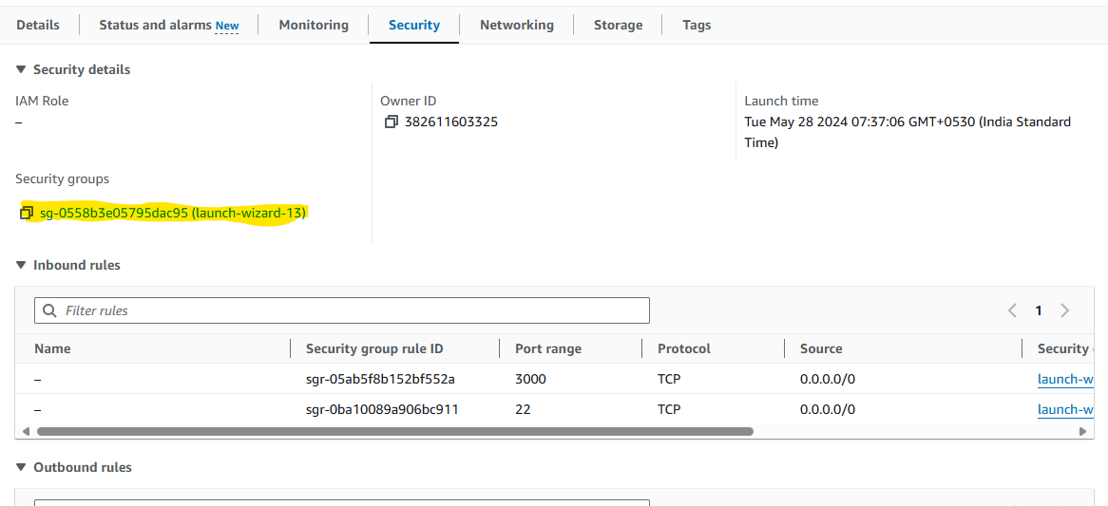

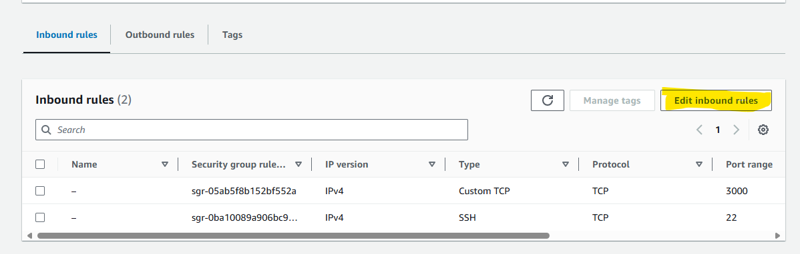

Here we have port No. for backend application in server.js file.

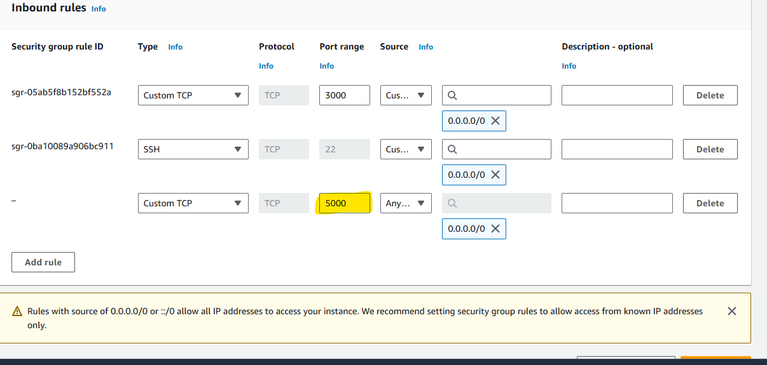

1. Here permanent deployment have completed, now you can check it by entering public IP along with port No. in URL of any browser.

===> <publicIP>:<PortNo.>

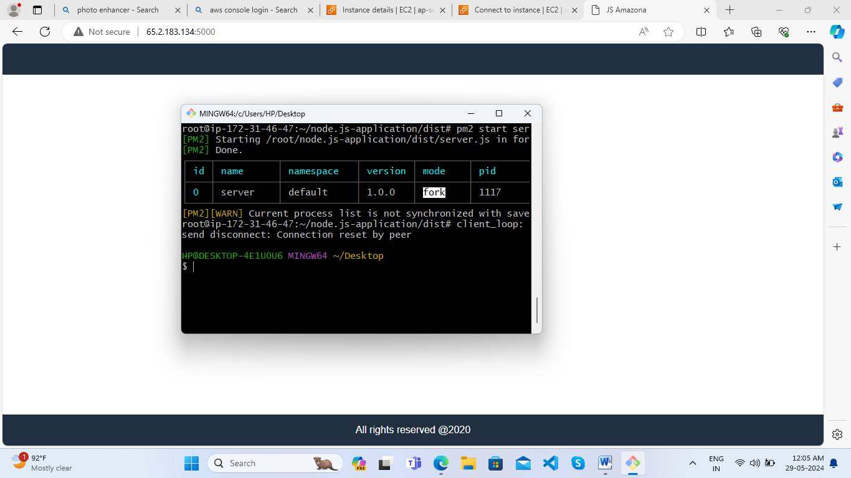

**Some pm2 commands:**

* **pm2 logs** => It gives the logs of pm2.

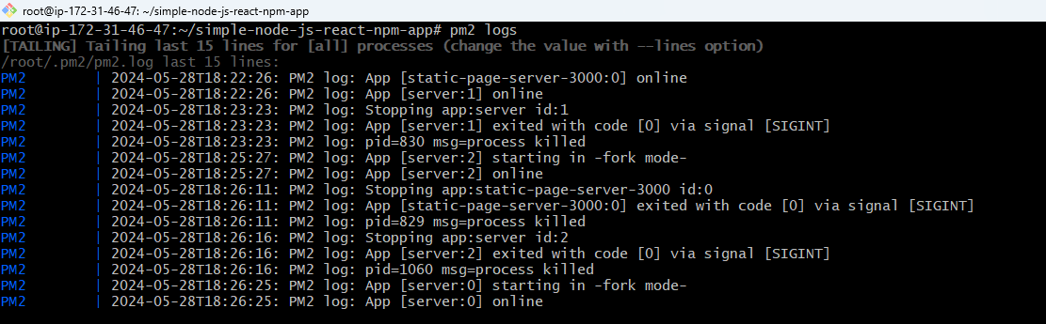

* **pm2 ls** => it gives list of applications that are online.

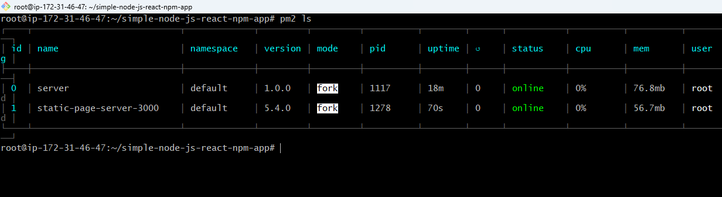

* **pm2 show <id>** => It gives the full information of the application running in given id

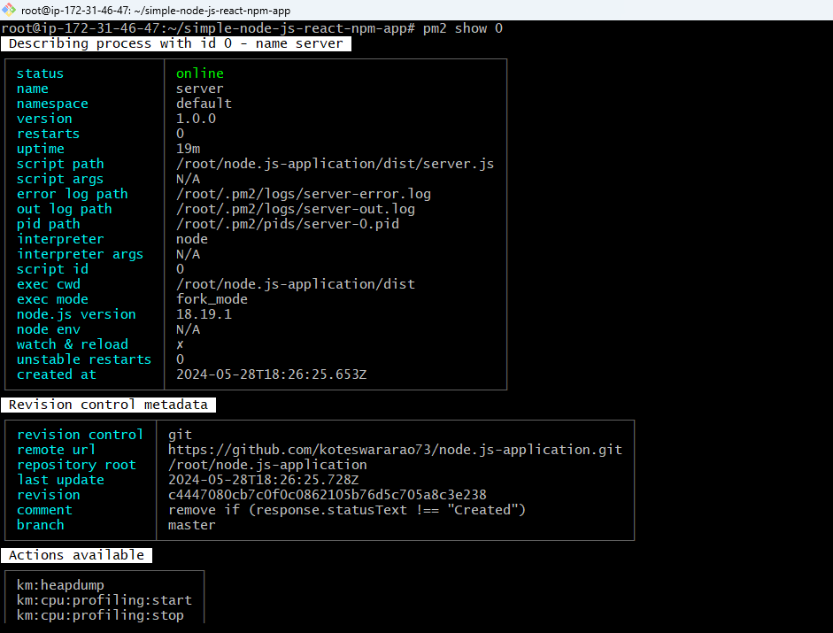

* **pm2 monit** => It helps to mointer the servers that are live.

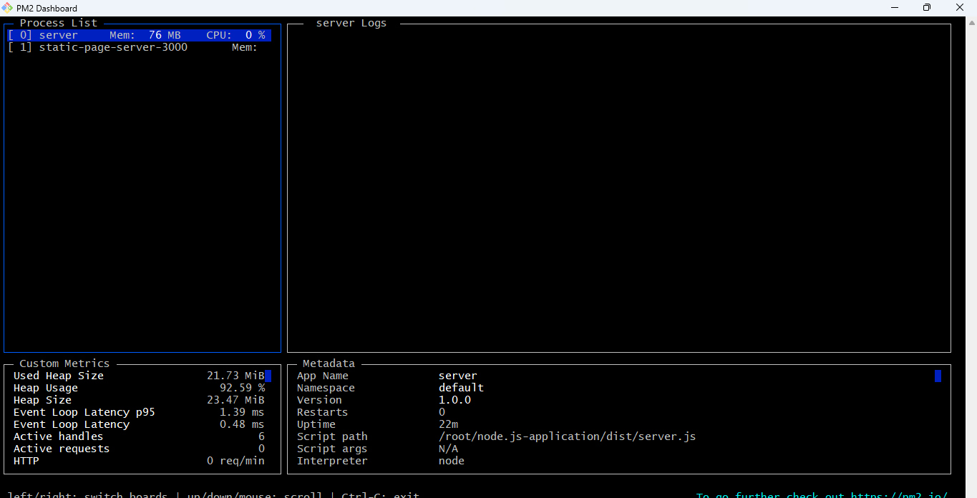

We have to use ‘ctrl+c’ to exit monit mode.

* **pm2 delete <id>** => Delete the running application present in given id.

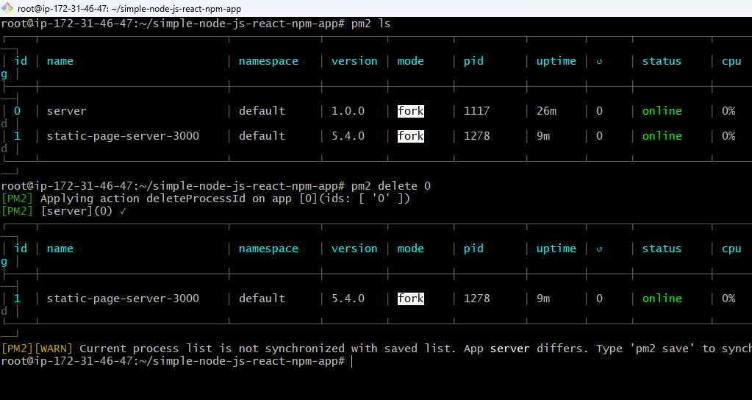

* **pm2 delete all** => Deletes all running applications from pm2.

